Fernando Colman

CS 6375

March 27th 2023

Project 3

Accuracies and F1 Score for each Dataset for each model

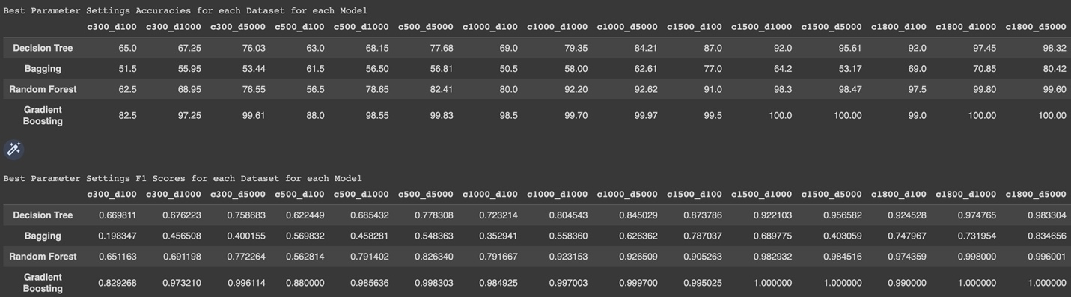

Q5.

* Which classifier (among the four) yields the best overall generalization accuracy/F1 score? Based on your ML knowledge, why do you think the “classifier” achieved the highest overall accuracy/F1 score.
  + The gradient boosting classifier had the best overall accuracy and f1 score for every single dataset. I believe the reason the gradient boost classifier is the best is because it is an ensemble algorithm that not trying to just predict outcomes but also improve the mistakes of previous learners. Furthermore, the gradient boosting algorithm is by far the longest algorithm to compute.
* What is the impact of increasing the amount of training data on the accuracy/F1 scores of each of the four classifiers.
  + For all four classifiers, increasing the amount of training data improves both the accuracy and F1 score.
* What is the impact of increasing the number of features on the accuracy/F1 scores of each of the four classifiers.
  + For all four classifiers, increasing the number of features improves both the accuracy and F1 score.

Q6.

* Evaluate the four tree and ensemble classifiers you used above on the MNIST dataset from Project 2 (do not compute F1 scores on MNIST, just classification accuracy). Which classifier among the four yields the best classification accuracy on the MNIST dataset and why?
  + The gradient boost algorithm is still the best one compared to all the other classifiers for the same reason that it’s good with all the other datasets.

Q7.

* Compare the classification accuracy of tree and ensemble based classifiers with the (best) accuracy you obtained using the MLPClassifier, SVMs and nearest-neighbors in Project 2 (best as in after tuning the hyperparameters). Which classifier (or classifiers) among the seven has (have) the highest accuracy on the test set and why?
  + The gradient boost algorithm still has the best accuracy compared to all the other classifiers for the same reason listed above.